Communities
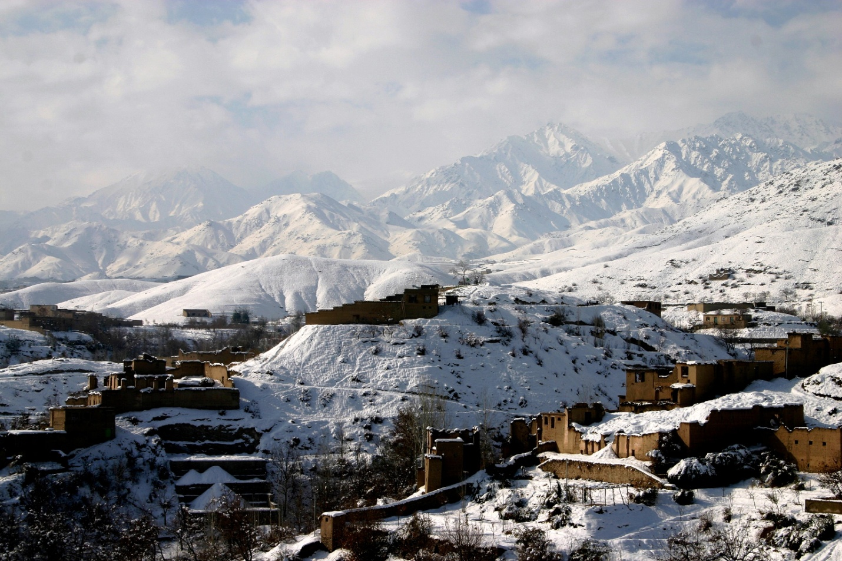
Istalif, Afghanistan

Who: Some 43,000 people have returned to this rural area.

What: Istalif became one of the Taliban’s targets in July, 1999. They burned most homes
and destroyed property and agriculture before they were defeated in December, 2001.

When: Sozo arrived in July, 2002.

Where: Istalif is 30 miles north of the capital city of Kabul.

Why: Massive destruction in this area left thousands homeless, without basic necessities, suffering from
illnesses and disease, and a lack of resources for education.

How: Sozo began with relief, offering mobile medical clinics, food and clothing distributions. Sozo met with
Istalif leaders and developed a plan to stem the outbreak of a disfiguring skin disease, called Leishmaniasis.
Sozo helped establish a network of volunteer Community Health Workers (CHW) and a medical clinic for the
area. Sozo also began providing supplies and support for some of the area’s schools.

Learn more at: www.SozoInternational.org
Sozo International, P.O. Box 436967, Louisville, KY 40253
Phone: (502) 253-4308 ● Fax (502) 253-3994
e-mail: info@sozointernational.org

